**ESIMATION OF BUSINESS EXPENSES**

1) INTRODUCTION:

DEFINITION:

Estimate in business refers to the value or quantity of something that is approximate and not exact. It is a statement or calculation of expected costs, revenues, or profits. In business, an estimate is based on past experience and knowledge of current trends. It is generally used when there is uncertainty about future. An estimate can also be used to calculate the cost of a project.

PRINCIPLE:

The basic concept of estimating is to break down project (buildings, road, bridge) into industry-standard trade packages. When you consider there may be between 50 to 100 trades on most building projects and then each trade may have hundreds thousands of components.

PURPOSES:

Cost estimates help produce a reasonable budget for a ask r project. For this to happen estimates should be both accurate and consistent. An estimate, which approximates the cost to accomplish work, is needed to assist key personnel by allowing them to make informed decisions.

2) PROBLEM DEFINITION & DESIGN THINKING

(2.1) EMPATHY MAP:

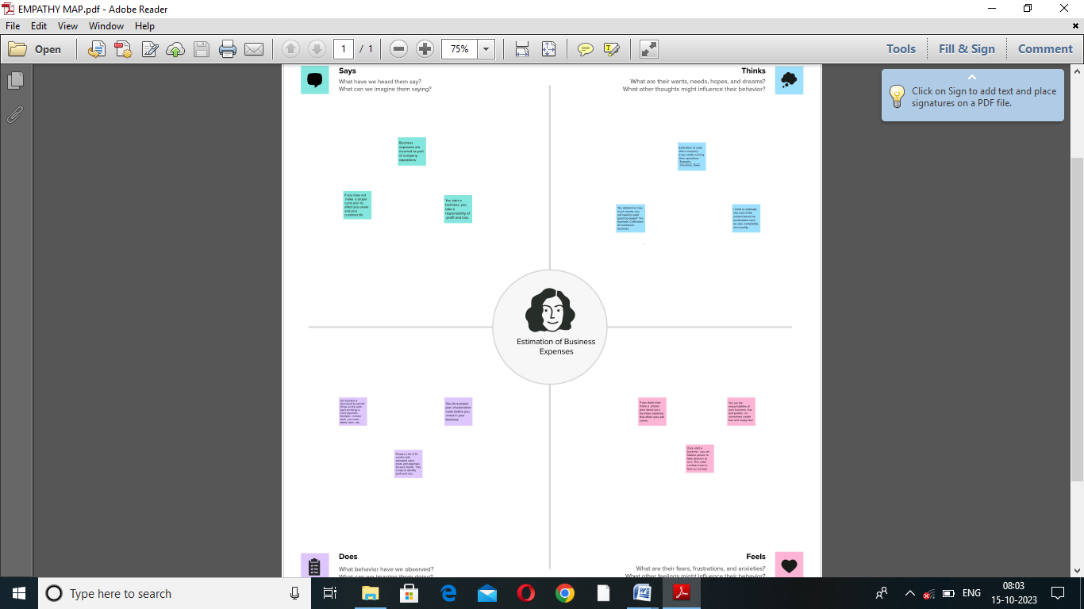

(2.2) DASHBOARD:

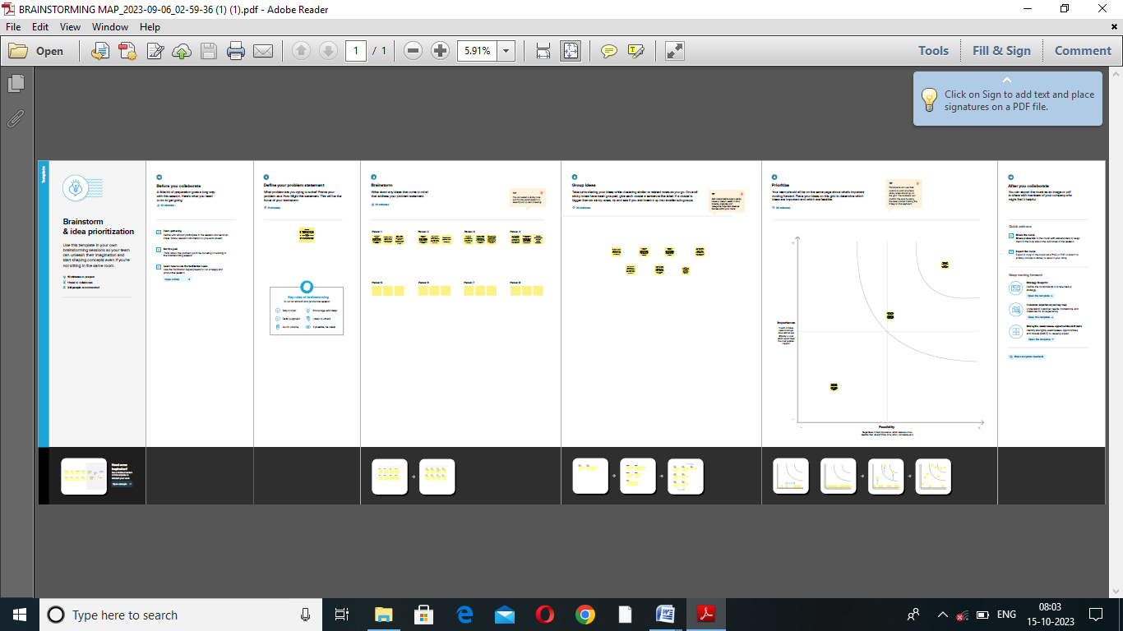

(3) DESIGN OF DASHBOARD

(3.1) DASHBOARD 1: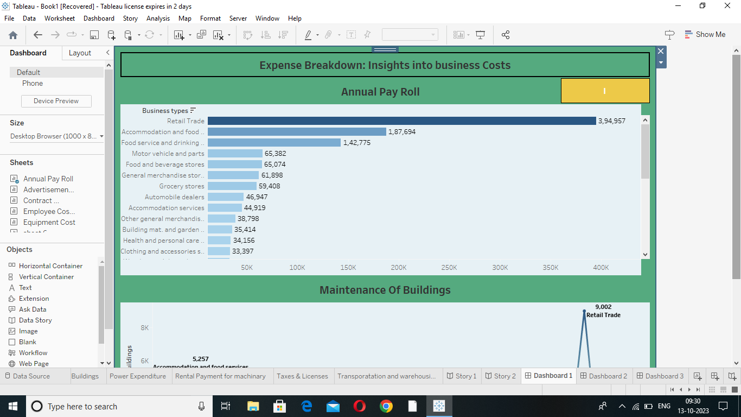

(3.2)DASHBOARD 2:

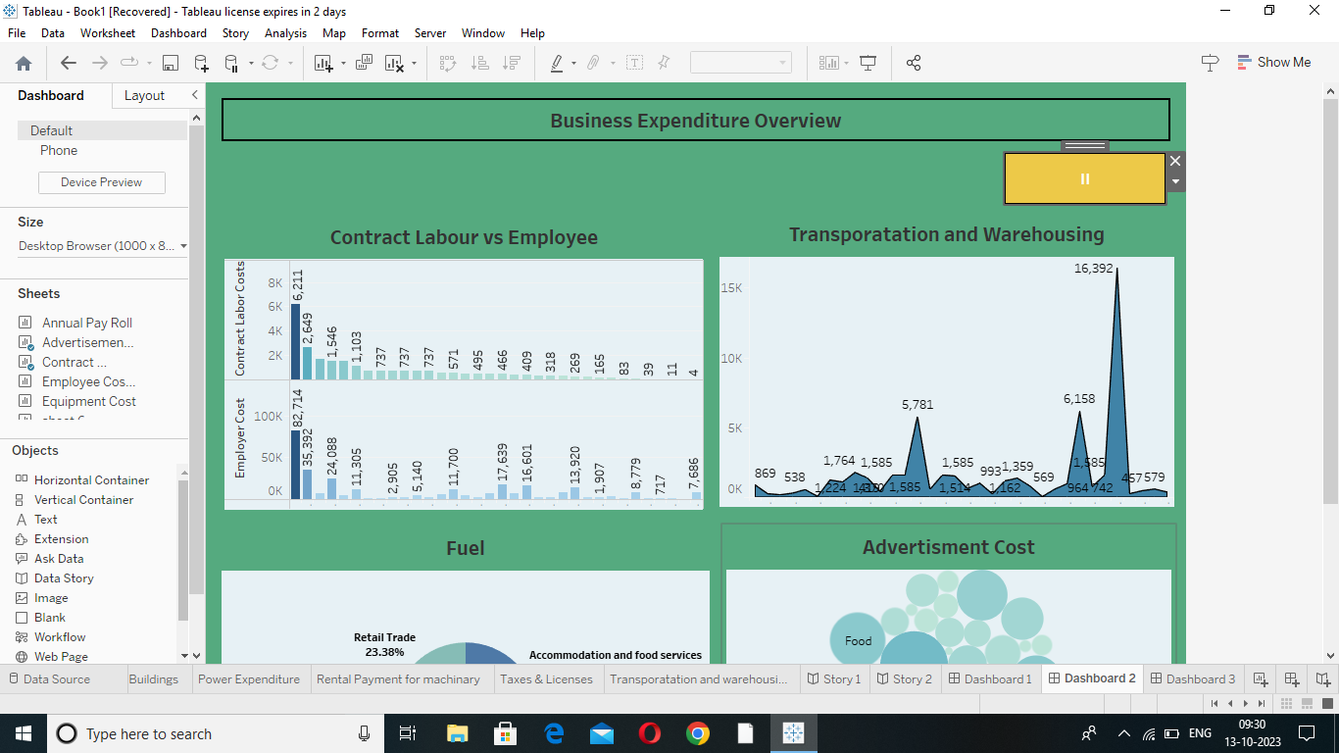

(3.3) DASHBOARD 3:

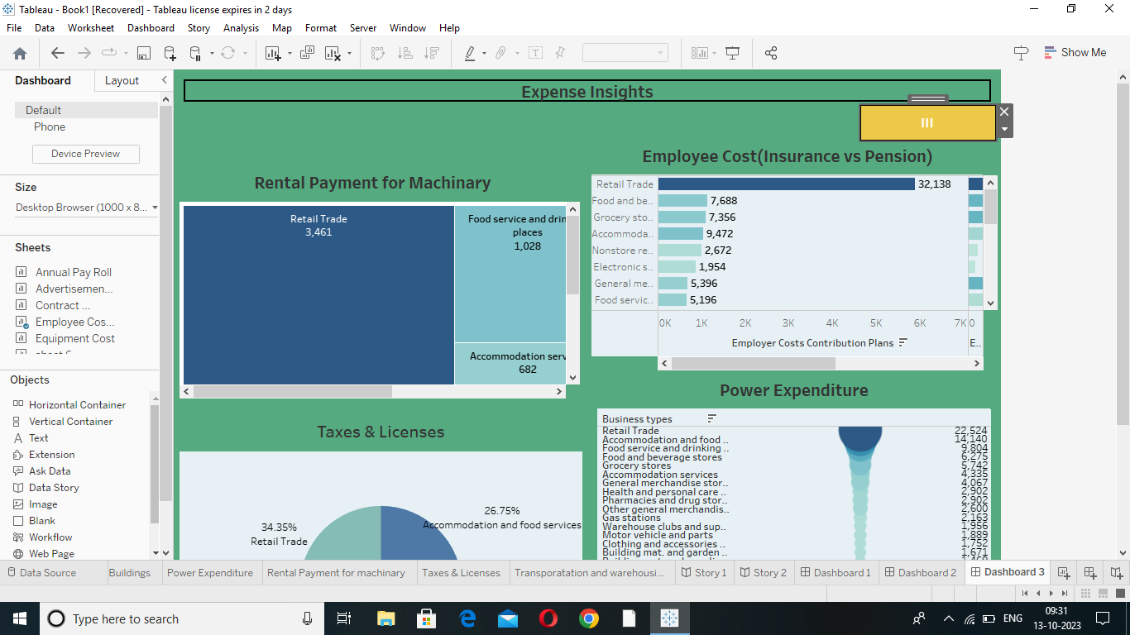

4) STORY

(4.1) STORY 1

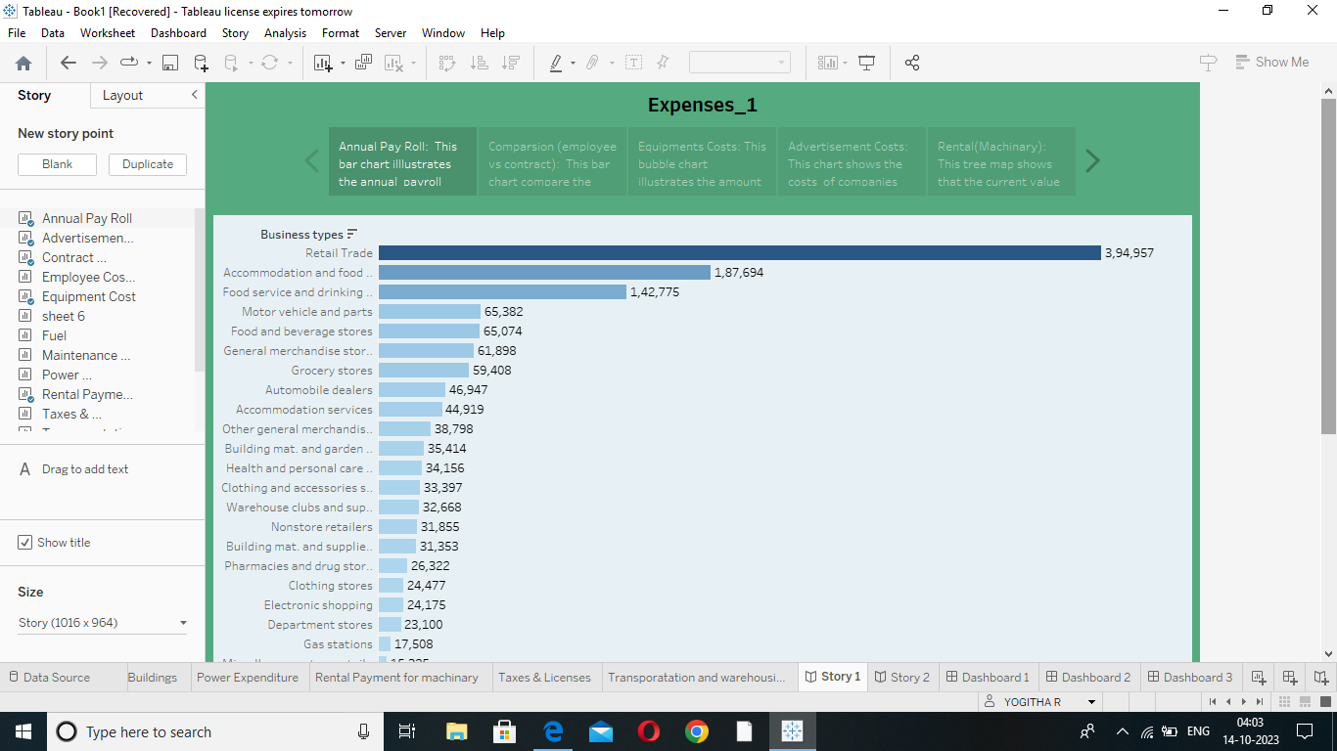

(4.2) STORY 2:

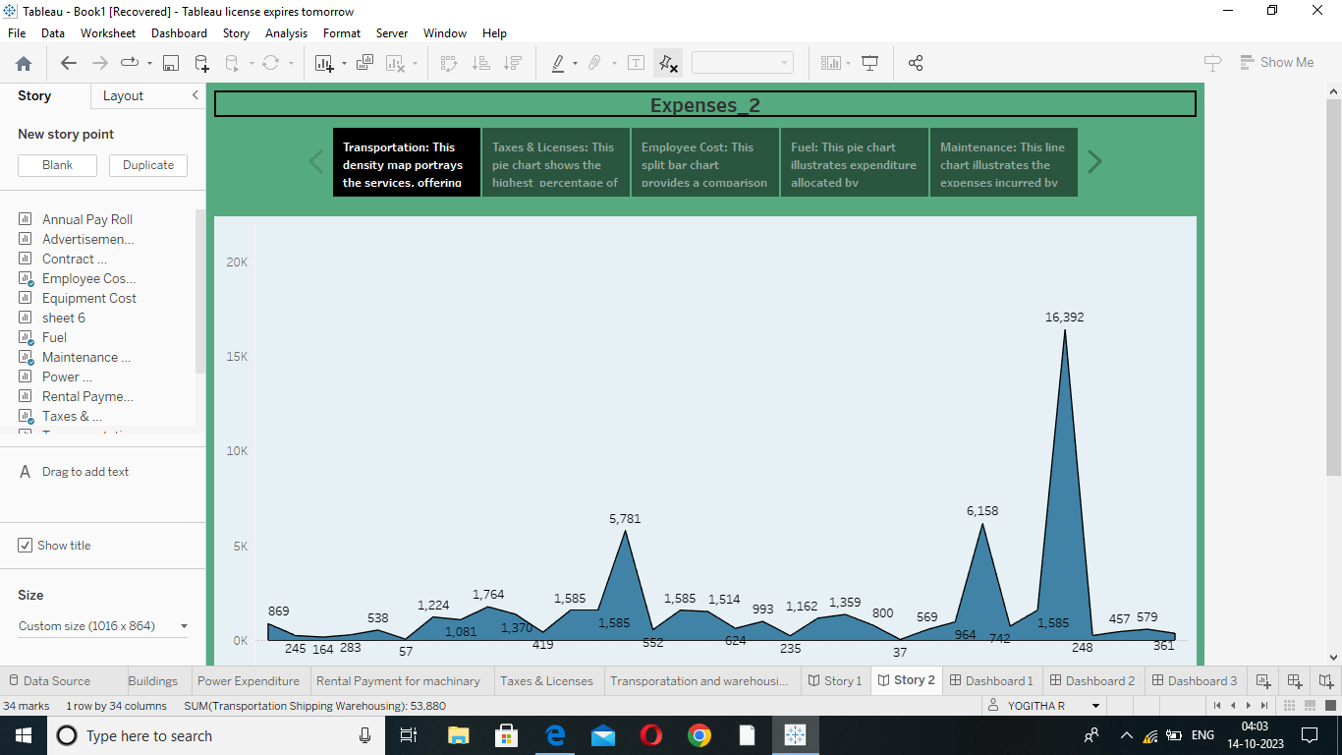

ADVANDAGES :

* Helps in sting prices.
* Identifies unnecessary costs involved.
* Enhances productivity.
* Helps the management make effective decisions.
* A more accurate view of the costs and profits expected in each project.

DISADVANTAGES:

* Records past data.
* Costs keep changing every interval.
* Expertise required.
* Expensive maintenance.

APPLICATION:

Business expenses are ordinary and necessary costs a business incurs in order for it to operate. Businesses need to track and categorize their expenditures because some business expenses can count as tax deductions. Deductible expenses reduce a business taxable income, which can result in significant cost savings.

FUTURE SCOPES:

* Collect project requirements.
* Define Scope.
* Create Work Break-Down structure.
* Define a baseline for performance measurements and control.
* Improve the accuracy of cost, schedule, and resources estimates.